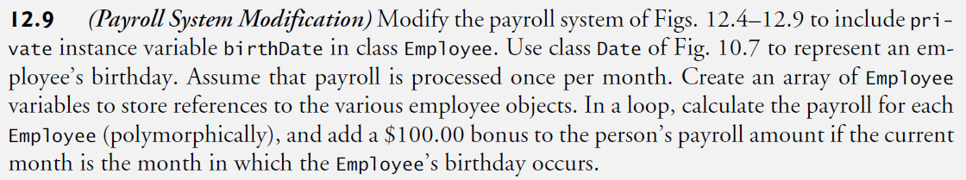

* (Payroll SystemModification) Modify the payroll system of Figs. 12.4–12.9 to include private instance variable birthDate in class Employee.
* Use class Date of Fig. 10.7 to represent an employee’s birthday.
* Assume that payroll is processed once per month.
* Create an array of Employee variables to store references to the various employee objects.
* In a loop, calculate the payroll for each Employee (polymorphically), and add a $100.00 bonus to the person’s payroll amount if the current month is the month in which the Employee’s birthday occurs.